INSTRUCTION FOR APPLIANCES

Up to date manuals for the dishwasher, washer-dryer and oven can be found on the ‘useful documents’ section of the website (www.astorchamonix.com)

Here are the cycles on the washing machine:

SPEAKER
There is a Bluetooth speaker near the TV. Sometimes there is interference when this is plugged in. If this occurs, remove from the power source whilst using but please replace charging wire when you have finished using so it is fully charged for the next guest.

DREAMSTREAMS IPTV
We have IPTV with English freeview and paid channels, Sky Sports and Movies in multiple languages. Turn the TV on using the black TV remote and select HDM1 using the source button.
Turn the android TV box on using the android tv box unbranded remote.
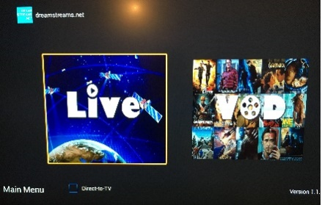
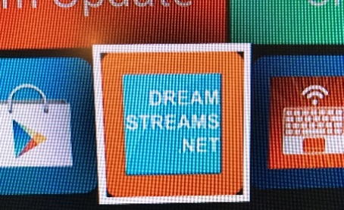
Click the Dreamstreams.net icon Select Live TV > You’re good to go!

Select VOD (Video on demand) for access to thousands of movies that can be streamed.

NINTENDO WII – ENSURE THE ANDROID TV BOX IS TURNED OFF
To use the Nintendo Wii you have to change the input on the TV. In order to do this use the black Toshiba TV remote.
Press ‘Input’ button. Scroll down the list by using the arrows and then press ‘OK’ to select the option you require.
3C is Nintendo Wii.

ORANGE (FRENCH TV)
Orange TV is on HDMI 2

Spare batteries for all remotes and handsets can be found in the drawers underneath the TV.

